UT Lands Oil Reporting Process Deployment

**Step 1:**

Run the scripts in the order below in the Quorum custom database. These will setup the tables and stored procedure that the report process will use.

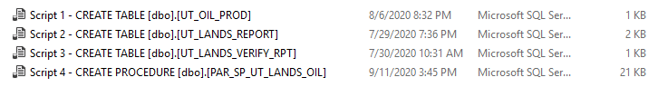

**Step 2:** Create a code table for the recently created table “UT_OIL_PROD”.

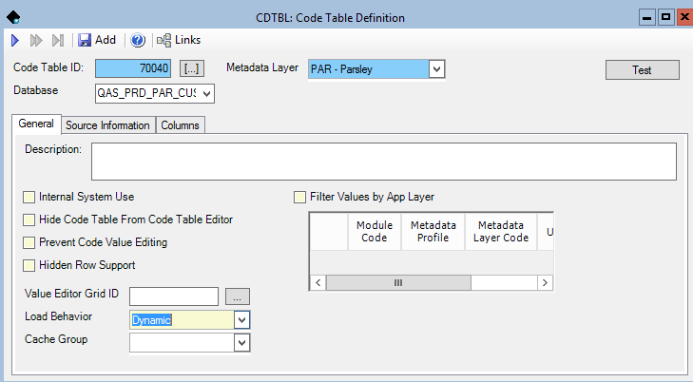

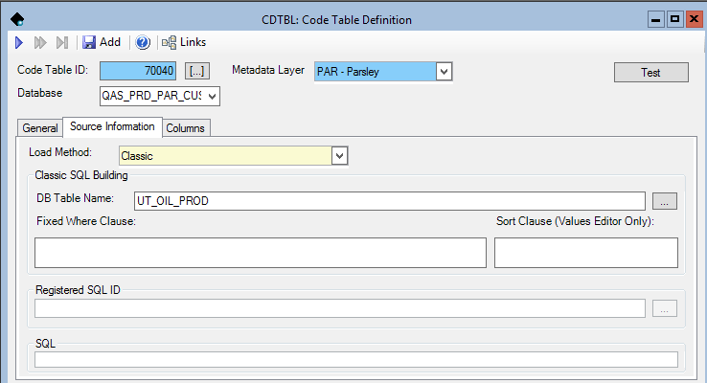

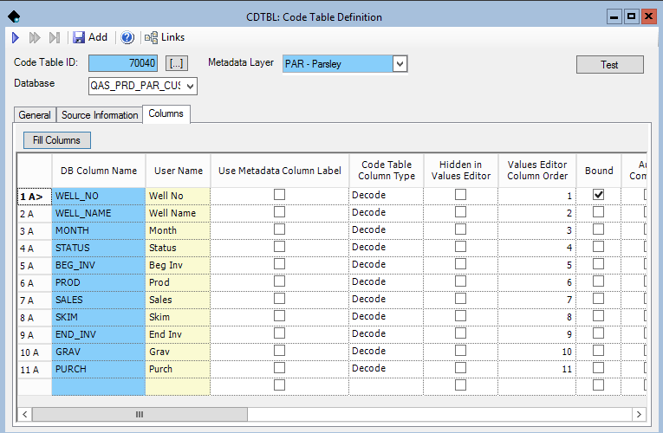

**Step 3:** Setup the Batch Process Step below in the maintenance app.

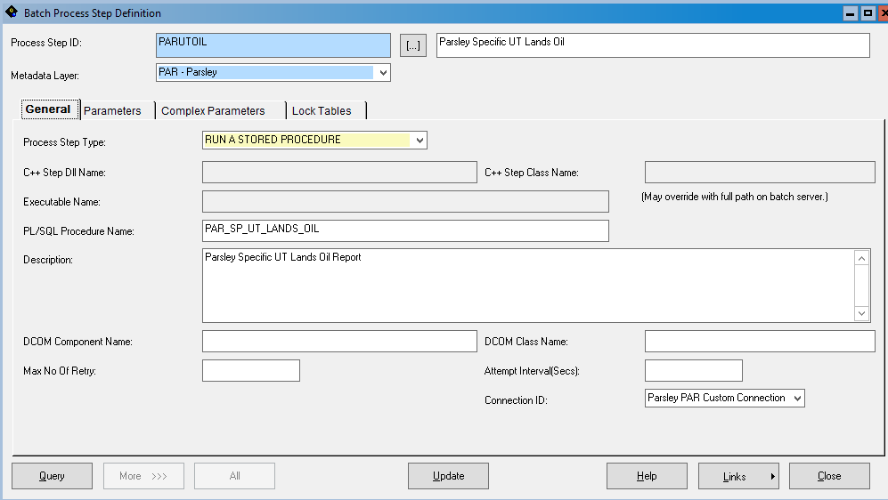

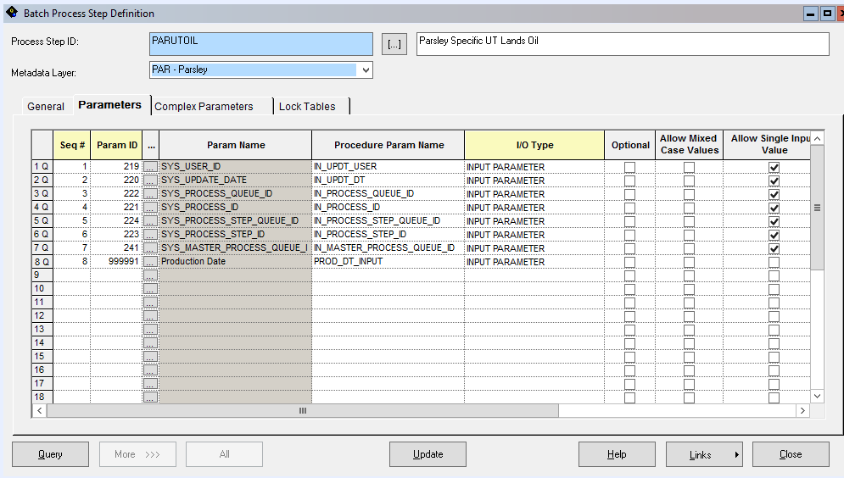

**Step 4:** Setup the Batch Process below in the maintenance app.

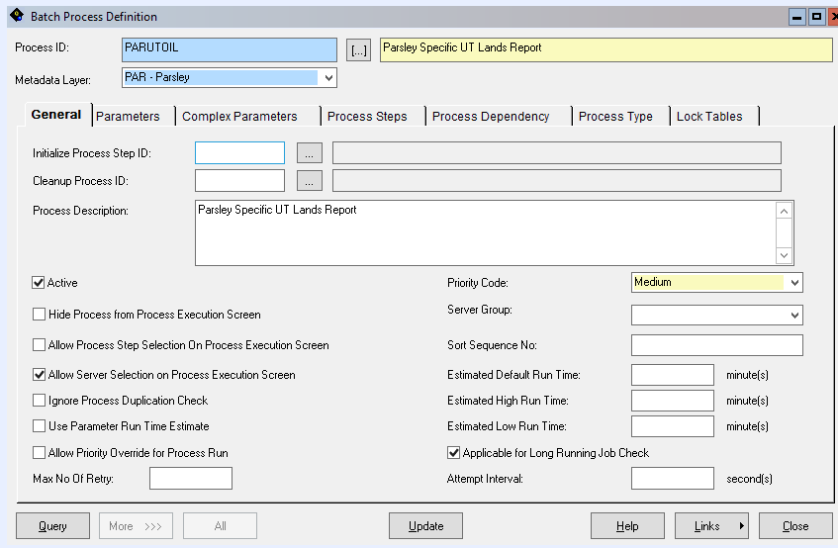

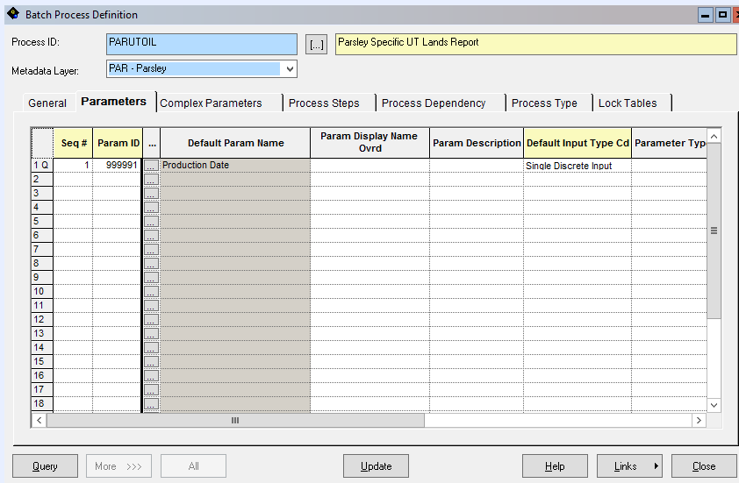

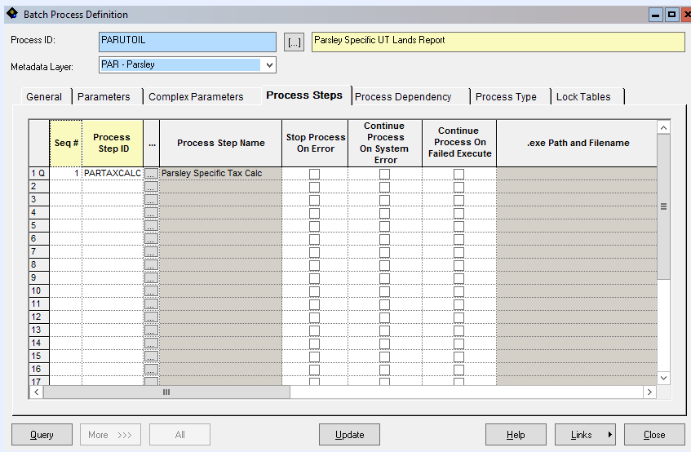

**Step 5:**

Setup the newly added process under the batch type “Royalty Reporting”

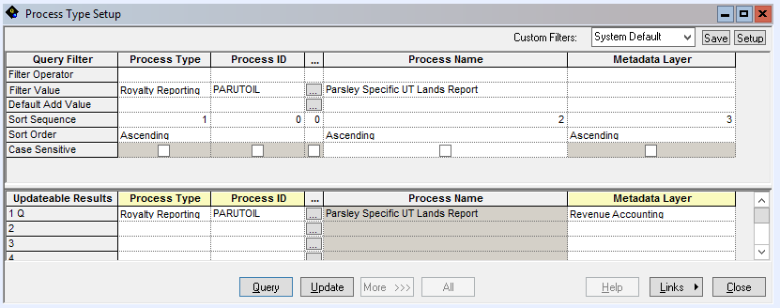

**Step 6:**

Add security for the newly created code table to security group “57100: QRA_TAX_&_REG-DATA ENTRY”

